Personality and Learning and Studying Behaviors in SPSS
Some of our questions give us demographic information on our participants. For these (questions 1-6) you will just want to run descriptive statistics. In other words, you want to know how many freshman, sophomores, etc., there are so that you can give information about your sample.
First, we need to make sure the data is properly set up.
- What are your variables?
- Have you labeled values? Need to label gender and how you take notes!! DO gender today!
- Is the data in the correct measure?
To run descriptive statistics:
- Analyze descriptive statistics frequencies
- Click statistics tab
- Check off mean, std. deviation, minimum, maximum
There are also a few questions that do not work for running correlations (questions 11 and 14). For those, you would also get descriptive statistics (i.e. How many participants are tactile learners, how many are auditory, and how many are visual?).
To run correlations:
- Analyze correlate bivariate
  - Move over the variables you are assessing (i.e. Extroversion and GPA or help-seeking)
  - Make sure ‘Pearson’ is the correlation coefficient that is marked off
  - Click on ‘options’, select to get the means and SDs
  - Click OK
- Read output!

Example from our personality data:

Descriptive Statistics
 | Mean | Std. Deviation | N
E | 59.173 | 21.5475 | 81
SocialLearningHelp | 13.407 | 2.6916 | 81

Correlations
 |  | E | SocialLearningHelp
E | Pearson Correlation | 1 | .414**
 | Sig. (2-tailed) |  | .000
 | N | 81 | 81
SocialLearningHelp | Pearson Correlation | .414** | 1
 | Sig. (2-tailed) | .000
 | N | 81 | 81
**. Correlation is significant at the 0.01 level (2-tailed).

When you look at the correlations table above (2nd table), you can see that the correlations are replicated on each side. This is because the output is given as a matrix, so the relationship of Extroversion with Extroversion is 1 (it is the same thing – it’s the relationship with itself), but then you also have the relationship of extroversion and Social Learning and Help-Seeking behaviors.
If you look at the Sig., you will see the p value. Is it less than .05? Is your correlation significant?
We could write up these results in the following way:
A Pearson correlation was run to examine the relationship between the personality dimension extroversion and the likelihood that students exhibit social learning and help seeking behaviors. Results show that there was a significant correlation between extroversion and social learning and help-seeking (r = .414, n = 81, p = .001).

Let’s say that my second hypotheses also looks at social learning and help-seeking, but this time, I predicted that social learning will correlate with the personality dimension neuroticism – I hypothesized that the higher one scores in neuroticism, the less likely they will be to engage in social learning and help-seeking.
I run my correlation as described above, but this time I put in the Neuroticism (N) variable. (You can also put multiple variables in at once and see how they all correlate. See output on last page.)
Descriptive Statistics
 | Mean | Std. Deviation | N
SocialLearningHelp | 13.407 | 2.6916 | 81
N | 53.856 | 19.8761 | 80

Correlations
 |  | SocialLearningHelp | N
SocialLearningHelp | Pearson Correlation | 1 | -.350**
 | Sig. (2-tailed) |  | .001
 | N | 81 | 80
N | Pearson Correlation | -.350** | 1
 | Sig. (2-tailed) | .001
 | N | 80 | 80
**. Correlation is significant at the 0.01 level (2-tailed).

What does this output show? Are the results significant? In what direction is the correlation? Please write out the results here: ______________________________________________________________________________________________________________________________________________________________________________________________________________________________________________________________________________________________________________________________________________________________________________________________________
Correlation strength, as described by Evans (1996):
• .00-.19 “very weak”
• .20-.39 “weak”
• .40-.59 “moderate”
• .60-.79 “strong”
• .80-1.0 “very strong”
Creating a Scatterplot for your correlation:
- Graphs chart builder
- Select type of graph you want from the options along the bottom left
- For a correlation, you want a scatterplot
- Drag the scatterplot picture (the first one should be appropriate for your data) to the chart preview area above
- Then, select the variables you are analyzing from the variables list on the left and drag them to the X and Y axis (for this example, extroversion would be on the X and # of friends on the Y)
  - Generally, your independent variable, or the ‘cause’ variable would go on the x-axis and your dependent variable, or the ‘effect’ variable on the y.
  - For example, if you were looking at the relationship between a person’s height and the distance they can jump, you would expect that their height would influence the distance jumped – so the height is you independent variable and what you expect to impact the results, so it would go on the x-axis. The distance jumped would be your dependent variable and that would go on the y.

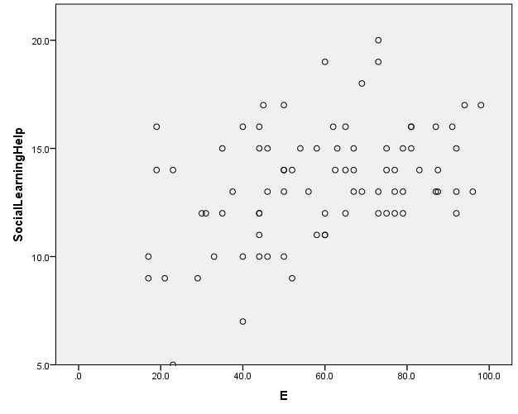

- Alternatively, Graphs Legacy dialogs Scatter/dot Simple Scatter
  - Scatter/Dot
  - Simple Scatter, click Define
  - What variable is on your Y axis?
  - What variable is on your X axis?

To insert line of best fit, double click on your chart in the output. Then in the top menu, click on Elements Fit line at total. Remove ‘attach label to line’.

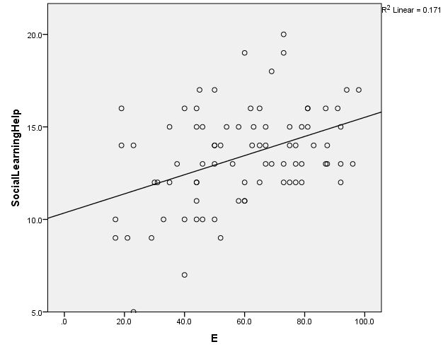

Correlations
 |  | SocialLearningHelp | N | E | A
SocialLearningHelp | Pearson Correlation | 1 | -.350** | .414** | .099
 | Sig. (2-tailed) |  | .001 | .000 | .378
 | N | 81 | 80 | 81 | 81
N | Pearson Correlation | -.350** | 1 | -.320** | -.208
 | Sig. (2-tailed) | .001 |  | .004 | .064
 | N | 80 | 80 | 80 | 80
E | Pearson Correlation | .414** | -.320** | 1 | .141
 | Sig. (2-tailed) | .000 | .004 |  | .211
 | N | 81 | 80 | 81 | 81
A | Pearson Correlation | .099 | -.208 | .141 | 1
 | Sig. (2-tailed) | .378 | .064 | .211
 | N | 81 | 80 | 81 | 81
**. Correlation is significant at the 0.01 level (2-tailed).

