Squirrel Observation Project
- Once we arrive at the park, choose one squirrel to observe. Make sure no one else from class is also observing the same squirrel. Follow that squirrel and observe its behavior for 20 minutes.
  - Do not interfere with the squirrel’s behavior in anyway.
  - If the squirrel ends up running far away, stop observing that one and find another squirrel.
- Use the attached ethogram to record your data.
  - Have one partner be in charge of marking the ethogram while the other constantly observes the squirrel.
  - ONLY record what you observe, NOT interpretations of potential consequences of behavior
- Once you finish 20 minutes with one squirrel, find a second squirrel to observe.
  - Start on a new ethogram sheet.
  - Switch roles with your partner, so that if you were marking the ethogram before, you will now solely be observing the squirrel and vice versa.
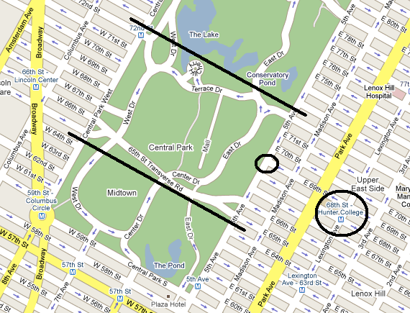
Eastern Gray Squirrel Ethogram
BEHAVIOR CLASS | BEHAVIOR | DESCRIPTION OF BEHAVIOR
MOVEMENT | REST | NO MOVEMENT, EYES CLOSED
 | FREEZE | NO MOVEMENT, EYES OPEN, ERECT POSTURE
 | WALK | ANIMAL MOVES FROM PLACE TO PLACE SLOWLY
 | RUN | ANIMAL MOVES FROM PLACE TO PLACE QUICKLY
f | SALTATE | JUMPING LOCOMOTION, AS COMPARED TO RUNNING
 | CLIMB | ANIMAL CLIMBS OBJECT SUCH AS TREE OR BENCH
 | JUMP | ANIMAL JUMPS TO OBJECTS ABOVE GROUND
vocalization | CHIRP | SHORTER DURATION, QUIET BETWEEN PULSES
 | CHATTER | LONGER DURATION AND CONTINUOUS
food related | SEARCH | ANIMAL LOOKS AROUND GROUND, SNIFFING
 | EAT | ANIMAL CONSUMES ANY FOOD IT FINDS
 | DIG | ANIMAL DIGS IN GROUND OR BURIES ITEM
 | DRINK | ANIMAL CONSUMES LIQUID IT FINDS
other activity | GROOM | ANIMAL SMOOTHES ITS FUR OR SCRATCHES
 | TAIL FLICK | ANIMAL FLICKS TAIL FROM SIDE TO SIDE
 | SIT | ANIMAL SITS UP ON HAUNCHES, ALERT

After the observations, research questions and hypotheses will be developed. Squirrel behavior from the fall semester will be compared to previous observations of squirrel behavior in the spring. Students will enter their observation data into a group database. All observations will then be used together to calculate differences between squirrel behaviors in the two seasons.
Goals:
- Experience observation as a research tool; consider strengths and weaknesses of this approach
- Consider strengths and weaknesses of ethogram
- Develop research questions and hypotheses
- Analyze data

